Multivariable Control Course 3 – Observer-Based Control

# Exercise 1

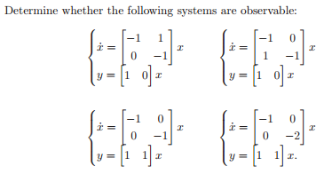

## a)

Make the Observability matrix, if it is full rang then the system is observable.

$$O= \left[\begin{matrix}C \\ CA\end{matrix}\right]=\left[\begin{matrix}1 & 0 \\ -1 & 1\end{matrix}\right]$$

$$\det\left(O\right)=1$$

The observability matrix is full rang.

## b)

$$O= \left[\begin{matrix}C \\ CA\end{matrix}\right]=\left[\begin{matrix}1 & 0 \\ -1 & 0\end{matrix}\right]$$

$$\det\left(O\right)=0$$

The observability matrix is not full rang.

## c)

$$O= \left[\begin{matrix}C \\ CA\end{matrix}\right]=\left[\begin{matrix}1 & 1 \\ -1 & -1\end{matrix}\right]$$

$$\det\left(O\right)=0$$

The observability matrix is not full rang.

## d)

$$O= \left[\begin{matrix}C \\ CA\end{matrix}\right]=\left[\begin{matrix}1 & 1 \\ -1 & -2\end{matrix}\right]$$

$$\det\left(O\right)=-1$$

The observability matrix is full rang.

# Exercise 2

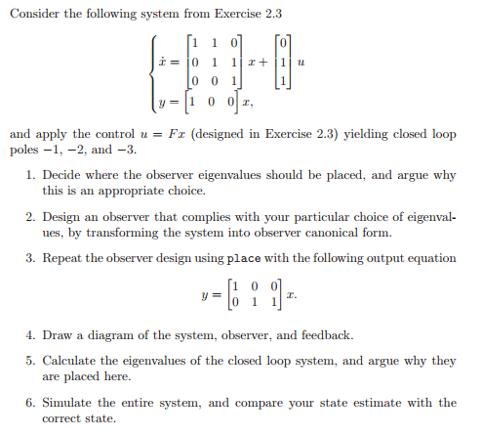

## a)